**Dice Rolling**

**Input:**

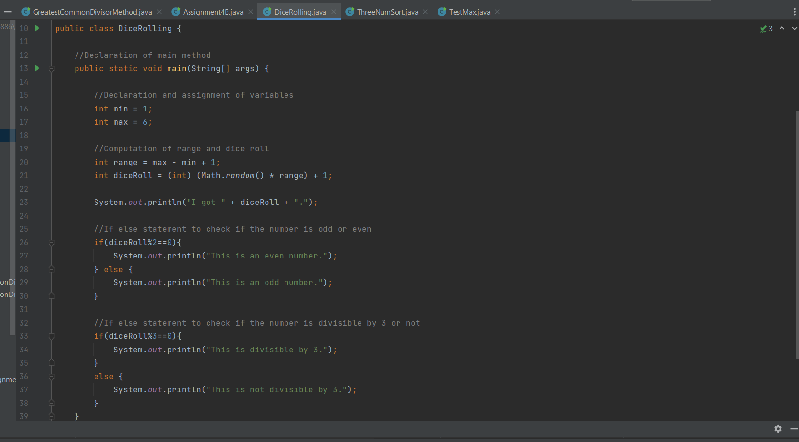

**Output:**

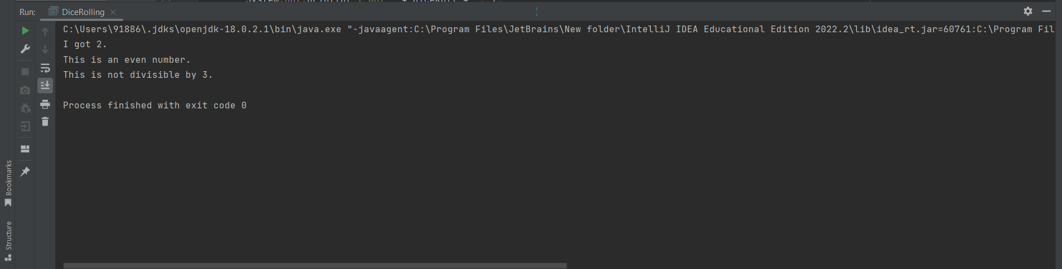

The dice rolling code was interesting, and I did not face much difficulty in it. The logic to apply was how to get even number, and a number which is divisible by 3 using if statement which I was able to troubleshoot easily. Thus, was able to complete it without spending much time in it.

**Three Number Sort**

**Input:**

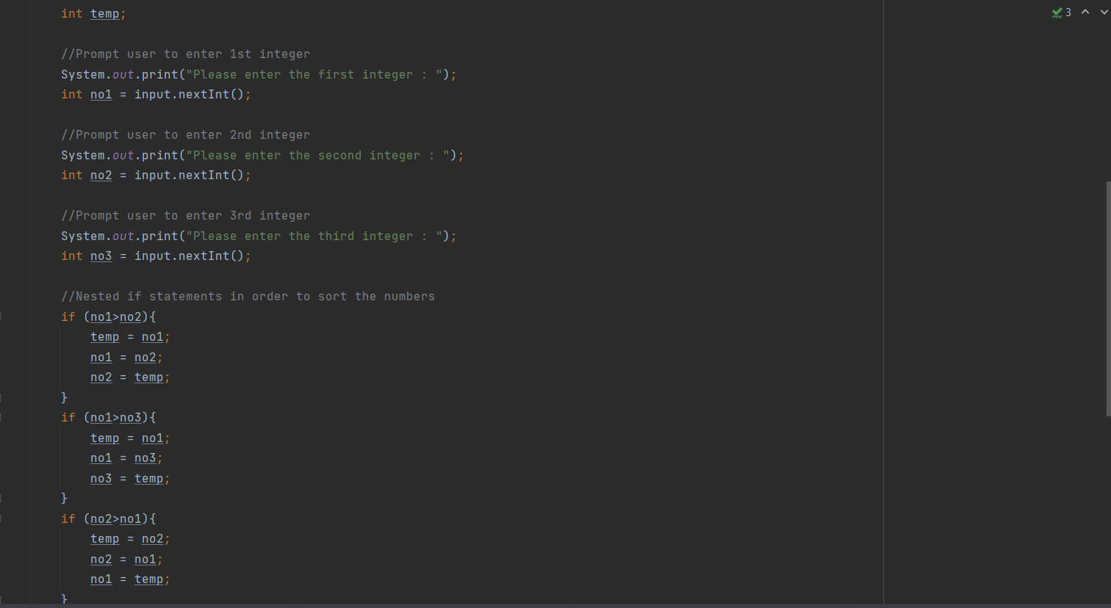

**Output:**

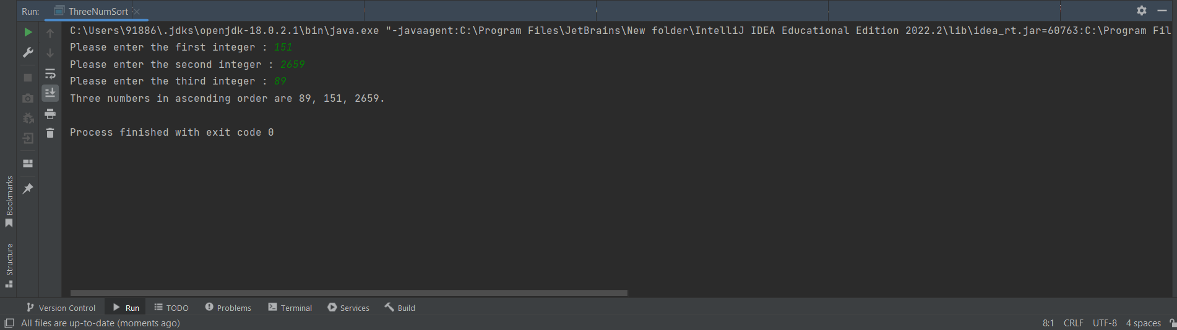

The three number sort task was a bit tough. At the beginning, it was strenuous to write the logic of if statements. I also tried various methods, and then finally submitted the most convenient one. The first method I used was too long and tiresome that is I needed to first note down after thinking a lot, then execute the code. Additionally, it also involved many print statements which might confuse one. Finally, I agreed upon to finalize this method wherein I first need to declare a temporary variable. Then swap the values according to the condition, and finally get an output. Though it took time, I enjoyed doing it as well as I learned few new concepts.